Lab#9 – Object Oriented Programming Part1
Name | Ben Stobie
Date | 16/04/21

Exercise 1: Classes and Objects
Copy your Python code from the first exercise here. Make sure that your code contains your name and date.
#Ben Stobie
#16/04/21

class Student:
def __init__(self, fname, lname):
self.first_name = fname
self.last_name = lname

def main():
studentName = Student(input("Please enter your first name: "), input("Please enter your last name: "))
print(studentName.first_name, end = " ")
print(studentName.last_name)

main()
#Ben Stobie
#16/04/21

class Student:
def __init__(self, fname, lname):
self.first_name = fname
self.last_name = lname

def main():
studentName1 = Student(input("Please enter your first name: "), input("Please enter your last name: "))
studentName2 = Student(input("Please enter your partner's first name: "), input("Please enter your partner's last name: "))
studentName3 = Student(input("Please enter your partner's first name: "), input("Please enter your partner's last name: "))
print(studentName1.first_name, end = " ")
print(studentName1.last_name)
print(studentName2.first_name, end = " ")
print(studentName2.last_name)
print(studentName3.first_name, end = " ")
print(studentName3.last_name)
main()

Paste screen capture here showing some results
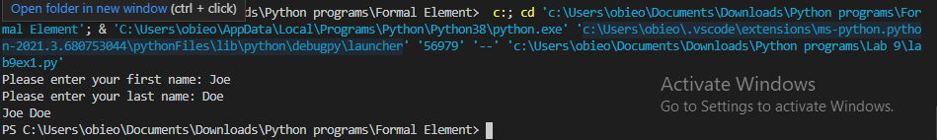
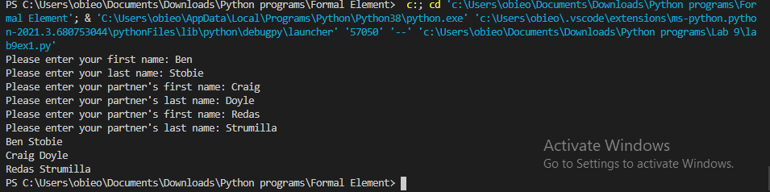

What is the difference between a class and an object? Give an example of each from your code.

The class is the container in which the objects exist, while the objects are the things withing the class that actually are a part of the execution.

How many instance variables are in the student class.
Code 1: 2
Code 2: 6

In exercise1 the instance variables are all “public”. What does being “public” mean?
That they can be called from outside the class, for example : studentName2.last_name

Exercise 2 - constructors
Copy your Python code here for exercise 2. Make sure that your code contains your name and date.
#Ben Stobie
#16/04/21

class Student:
def __init__(self, fname, lname, age):
self.first_name = fname
self.last_name = lname
self.student_age = age

def main():
studentName = Student(input("Please enter your first name: "), input("Please enter your last name: "), input("Please enter your age: "))
print(studentName.first_name, end = " ")
print(studentName.last_name)
print(studentName.student_age)
main()

Paste screen capture here showing some results
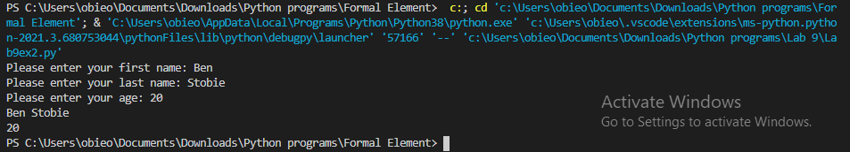

What is the purpose of the initializer in Python?
To initialize the object in order to begin operation.

Exercise 3/4 – data hiding
Copy your Python code here for exercise 3 and 4. Make sure that your code contains your name and date.
#Ben Stobie
#16/04/21

class Student:
def __init__(self, fname, lname, age):
self.__first_name = fname
self.last_name = lname
self.student_age = age

def main():
studentName = Student(input("Please enter your first name: "), input("Please enter your last name: "), input("Please enter your age: "))
print(studentName.first_name, end = " ")
print(studentName.last_name)
print(studentName.student_age)
main()

#Ben Stobie
#16/04/21

class Student:
def __init__(self, fname, lname, age):
self.__first_name = fname
self.__last_name = lname
self.__student_age = age

def __str__(self):
return (self.__first_name + " " + self.__last_name + " " + self.__student_age)

def main():
studentName = str(Student(input("Please enter your first name: "), input("Please enter your last name: "), input("Please enter your age: ")))
print(studentName)
main()

Paste screen capture here showing some results
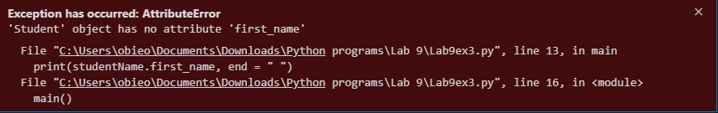
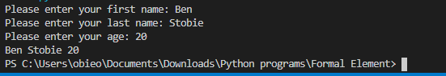

Explain what happened when your main code tried to access a private instance variables?
It returned an error as the variable it was trying to access was no longer public for it to access.

What is an “Accessor” method? Give examples from your code from exercise 3 and 4.

An accessor method is a method that accesses privated variables in an object without being able to change it’s state.

Exercise 5 – “set” methods
Copy your Python code here for exercise 5. Make sure that your code contains your name and date.
#Ben Stobie
#16/04/21

class Student:
def __init__(self, fname, lname):
self.__first_name = fname
self.__last_name = lname
self.__student_mark = []

def set_first_name(self, fname):
self.__first_name = fname

def set_last_name(self, lname):
self.__last_name = lname

def add_mark(self, mark):
self.__student_mark.append( mark )

def __str__(self):
c = 0
i = 0
ranVar = "Name: " + self.__first_name + " " + self.__last_name + " Marks: "
for c in self.__student_mark:
ranVar = ranVar + "" + c
if i != 2:
ranVar = ranVar + ", "
i = i + 1
return ranVar

def main():
i = 0
studentName = Student("", "")
studentName.set_first_name(input("Enter your first name: "))
studentName.set_last_name(input("Enter your last name: "))
while i < 3:
studentName.add_mark(input("Enter the various marks: "))
i = i + 1

print(studentName)
main()

Paste screen capture here showing some results
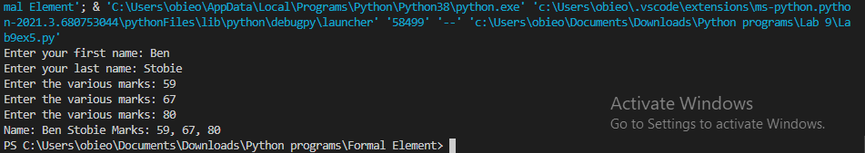

Explain the purpose of a “mutator” method and give an example of one from your code?

It allows the change of private data within Classes, it would be particularly useful if during a program a variable needed to change based on other circumstances, example: def set_last_name(self, lname):
self.__last_name = lname

